FLOWCHART
A Flowchart is a pictorial representation showing all of the steps of a process.

check sheet
The check sheet is a form (document) used to collect data in real time at the location where the data is generated.

Pareto chart
A Pareto chart is a bar graph that visually depicts which situations are more significant.
The chart is used to represent a set of data in a bar graph chart, with individual values represented by the length of the bars
Highest frequency first
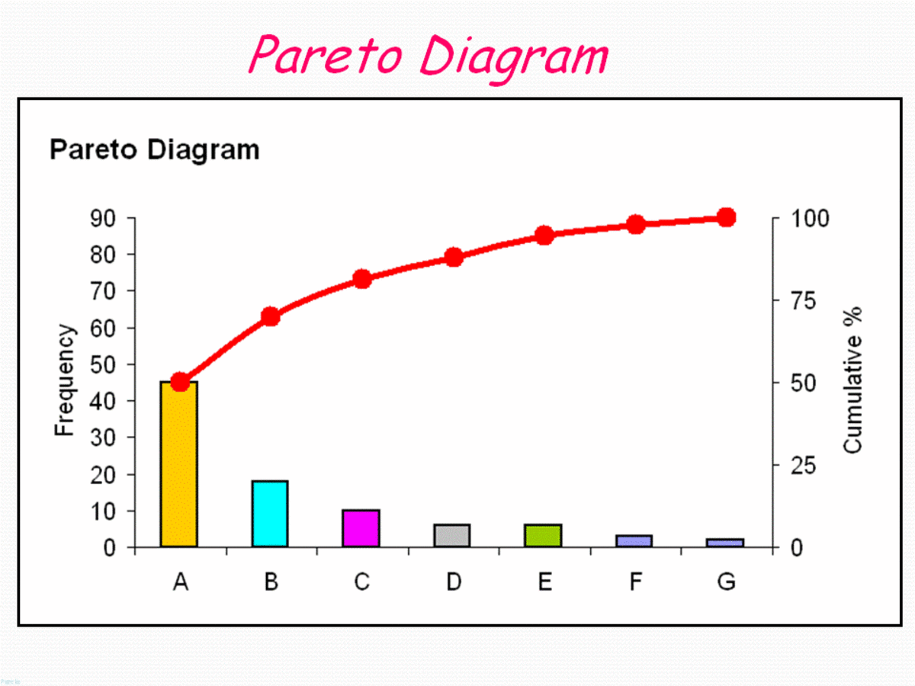
CAUSE & EFFECT DIAGRAM
represent the relationship between some “effect” and all the possible “causes” influencing it. The effect or problem is stated on the right side of the chart and the major influences or “causes” are listed to the left.

RUN CHART
That display data over time.
It is common to graph the results of a process such as machine downtime, yield, scrap, typographical errors, or productivity as they vary over time.
X-axis time sequence
Y-axis measurement

HISTOGRAM
A histogram is a visual representation of the distribution of quantitative data.
X-axis rang of value
Y-axis frequency.

Scatter Diagram
A Scatter Diagram is used to study the possible relationship between one variable and another.

Control charts
Control charts used in production control to determine whether quality and manufacturing processes are being controlled under stable conditions.

